ELECTRICAL AND ELECTRONICS

License

TO ADD

Contents:

1. Overall design concept
2. Range-limiting switches
3. Raspberry PI
4. Components for the base.
   1. Battery box
   2. …
5. Overall design concept

The design was somehow influenced by the parts we had in the lab. Especially, dynamixel servos have two communication models: TTL using a 3pin cable an connectors and IEE485, using 4 pins.

We placed all the 3pin-servos in the hand and had to allocate one USB2Dynamixel to the hand. All the 4pin-servos were placed in the base and at the bottom of the mast. So, a second USB2Dynamixel was used at the bottom of the mast.

Lots of wiring goes from the hand to the Raspberry Pi (3 USB cameras + USB2 Dynamixel) and from the arm holder to the PI (2 range limiting switches). It was therefore decided to attach the PI to arm. In that way, only two cables had to link the arm to the base: The 12 V (actually 11.1V) supply (base->arm) and the USB cable (arm->base) for the control of the lower group of servos.

As the PI is very light, its placement on the back holder of the arm has a negligible effect on performance.

The diagrams below are two ways of showing the wiring and components (missing range-limiting switches).





1. Range-limiting switches

TODO: IO connections, Pi code, etc

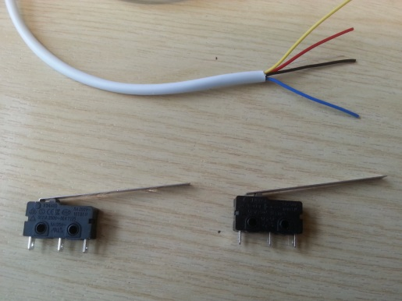

1. Raspberry PI: TO EXPAND – SEE ALSO SOFTWARE SECTION

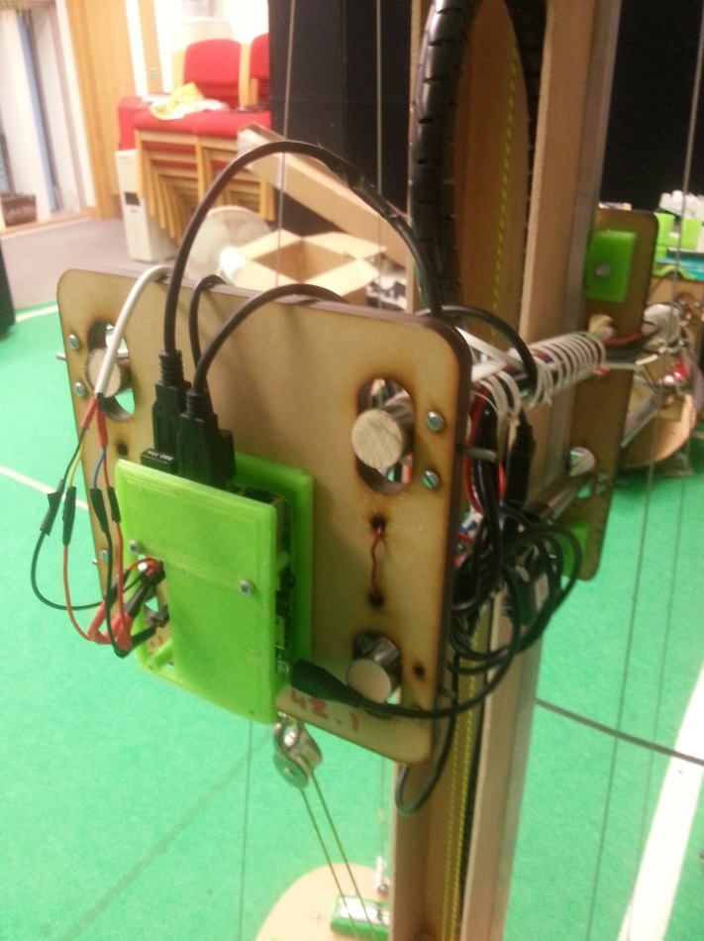

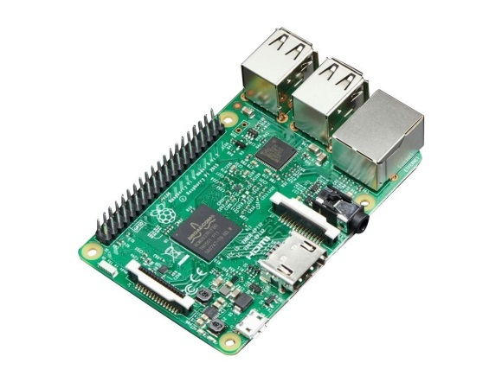

USB Hub.

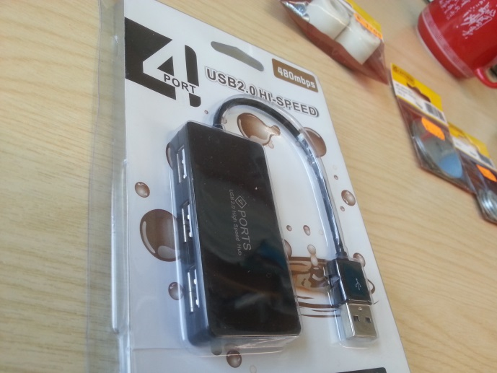

1. Components for the base:
2. Battery box

The battery box had been assembled from laser-cut parts (see 2D folder) and screwed onto the side of the mast. It has a power switch at the top.

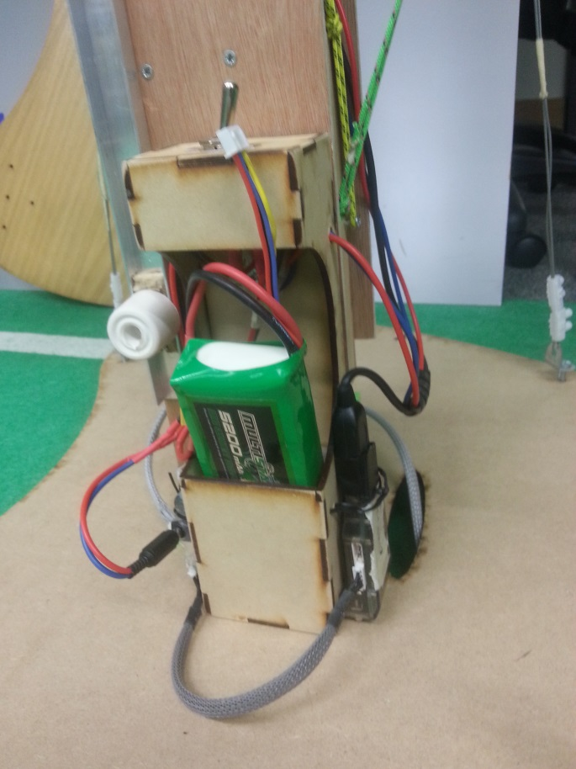 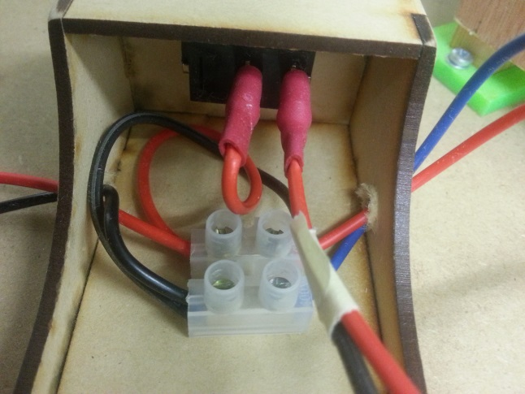

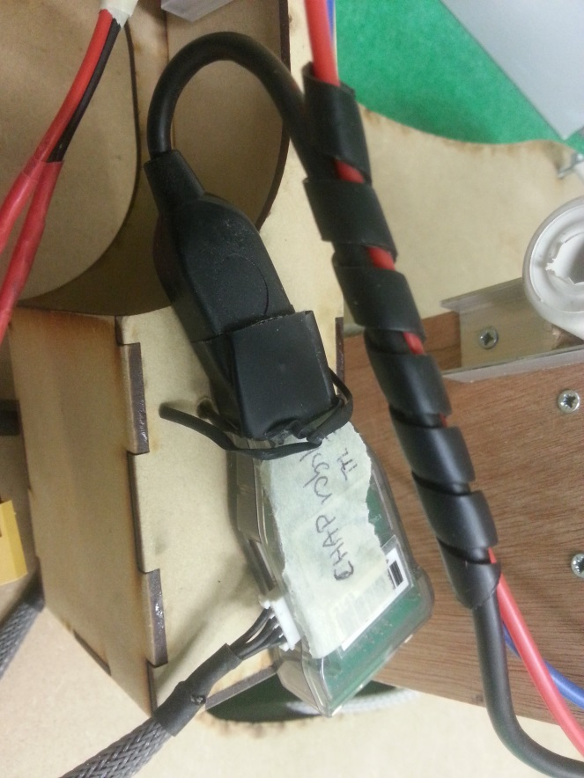 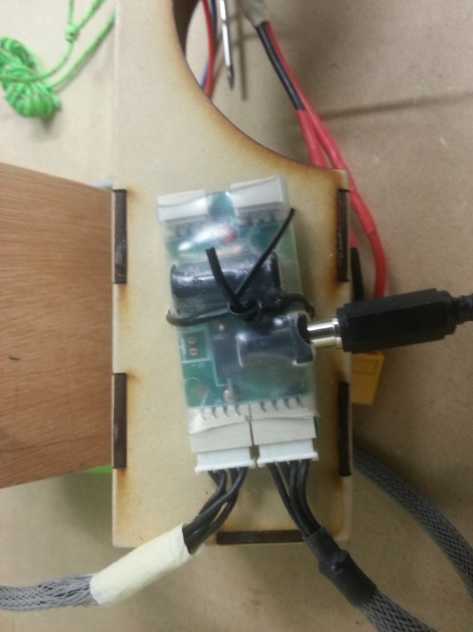

USB2 Dynamixel:

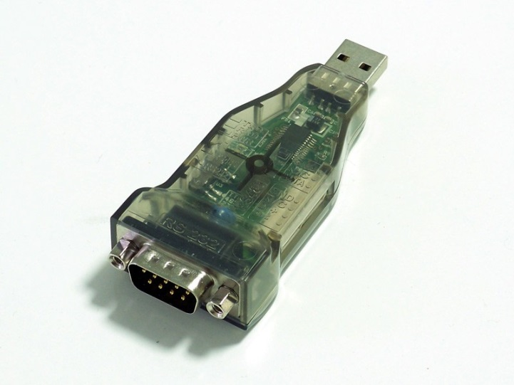

CABLE ( A 200mm 4pin cable cut in half then extended in the middle. Junctions protected by heat shrink tube.)

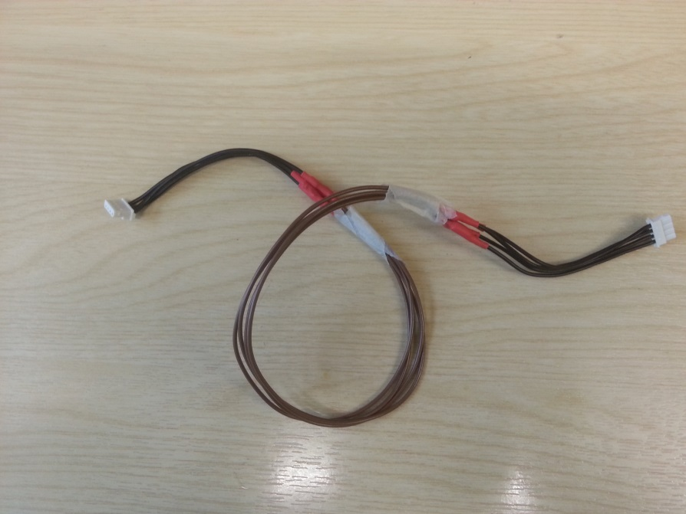

Battery with XT60 connector:



Female battery connector:

TO DO

SMPS2Dynamixel: Power supply interface for 11.1V to servos



Power plug.

TO DO